Pre Lab4
4X4 RAM implementation

Q1.
What is the difference between RAM and ROM?
RAM is “Random Access Memory” which means that an access to any address that it contains will take the same amount of time. RAM is also read writable and moderately fast. RAM is volatile which means that when power is removed from the system all of the data stored in RAM will be lost.
ROM is read only memory. Even though some times of ROM are read/writable (such as flash memory), it is still called as ROM since a majority of the operations are reads. ROM is nonvolative, it can lose power and the data stored in it will still persist. ROM is significantly slower than RAM.

Where do they fit in the microprocessor architecture?
RAM is the third level of the Memory Heirarchy. It is slower than registers and cache, but much faster than ROM. When things are moved out of cache, they are stored in memory. Memory is used as a large storage area for data that is not needed at the exact moment while a process is executing.

ROM is used to store persistent data. It is often used to store things wihle the system is powered off, or before it has even been moved into RAM. A software designer tries to ensure that data fetches never go to ROM because they are significatnly slower than other methods.

Q2.
Draw a basic block diagram of 4x4 ram and explain the signals associated with it?
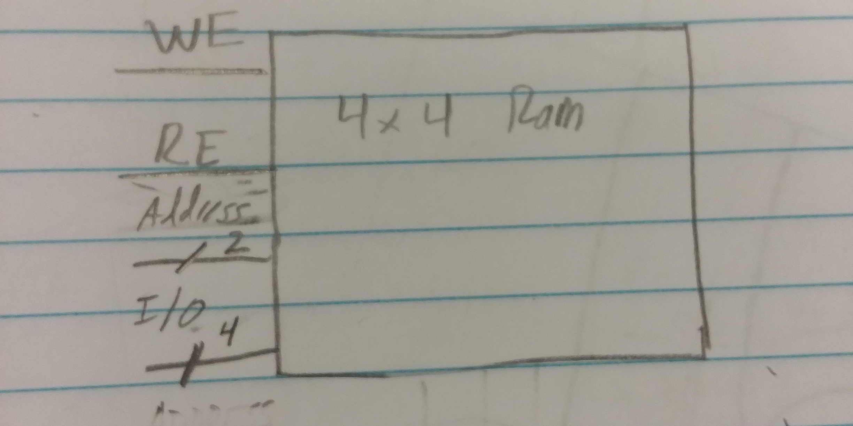
WE: Write enable. Drive high if you want to write to the ram. The inputs at the IO lines are written to the address given at the address line.
RE: Read enable. Drive high if you want to read from the address given at the address lines. The IO lines will be driven with the values at that address.
Address: 2 bits. The address to read or write from. You need 2 bits because there are 4 possible addresses, you need 2 bits for 4 values.
IO: 4 bits. Pins that are used for both input and output, depending on the values of WE and RE. There are 4 bits because each address stores a value that is 4 bits.

